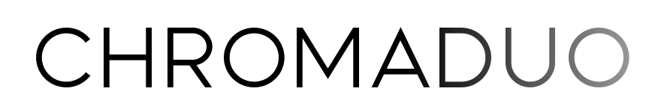
"Simply put, everything I heard blew my mind."
~ Jean-Baptiste Collinet
One of North America’s leading guitar ensembles, ChromaDuo shares uncommonly beautiful music with audiences throughout the world. For the past fifteen years, Tracy Anne Smith and Rob MacDonald have concertized across Canada and throughout the United States, as well as in Mexico, England, and Germany.
Passionate advocates for their art form, their deep creative connection allows audiences to immerse themselves fully into the music. The Iserlohner Zeitung observed, “As ChromaDuo sounded the first harmonies, you could hear a pin drop in the house of worship. Smith and MacDonald immediately captivated the audience.”
They are the dedicatees of works by top composers, including Roland Dyens, Stephen Goss, Dale Kavanagh, and Dušan Bogdanović. In the 2022/23 season they commissioned and premiered works by legendary Leo Brouwer, uncanny Canadian Amy Brandon, and iconic Brazilian Sergio Assad.
As Naxos recording artists, their music can be heard on all major streaming platforms.

